Flipkart Sales Analysis Report
Sales performance is a critical metric for any business, as it directly impacts revenue, growth, and customer satisfaction. Weekly sales reports help track trends, identify opportunities, and address challenges.
For this project:
- Dataset: Monthly sales transactions across multiple regions and product categories.
- Objective: Clean, preprocess, and transform raw data using Excel, ensuring accuracy and consistency.
- Dashboard: Created in Power BI to visualize KPIs, trends, and customer behaviour in a professional, interactive format.
- Real-world relevance: Simulates how retail chains or e-commerce platforms monitor sales performance and make strategic decisions.
What I Have:
- Raw Data: Original sales dataset containing order dates, product categories, sales amounts, and other relevant fields.
- Cleaned Data: Processed and cleaned version of the sales data in Excel, including removal of duplicates, arranging dates properly, and eliminating unnecessary data.
- Pivot Tables and Charts in Excel: Created pivot tables to summarize the three key performance indicators (KPIs):
  - Total Sales
  - Sales by Category
  - Monthly Sales Trends
Charts were developed based on these pivot tables to visualize trends and category performance.
Power BI Dashboard: An interactive dashboard was created in Power BI using the cleaned data to visualize the KPIs dynamically. The dashboard includes slicers and filters for detailed
data exploration.
Overview
This report summarizes the weekly sales analysis performed using Excel for data preprocessing and Power BI for dashboard creation. The goal is to provide actionable insights into sales performance, trends, and opportunities for improvement.
Tools Used
- Microsoft Excel
  - Data cleaning (removing duplicates, handling missing values)
  - Data preprocessing (standardizing formats, filtering)
  - Data transformation (pivot tables, pivot charts, slicers for interactivity)
- Microsoft Power BI
  - Dashboard creation with custom visuals
  - KPI cards for quick performance tracking
  - Interactive charts and filters for deeper analysis
  - Branding and design customization for professional presentation
Data Preparation Workflow
Step 1: Data Cleaning (Excel)
- Removed duplicate records
- Standardized date and product formats
- Handled missing or inconsistent entries 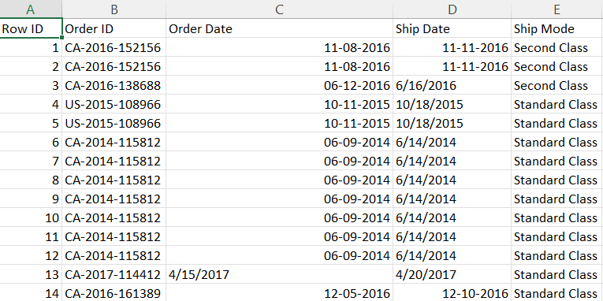
BEFORE CLEANING
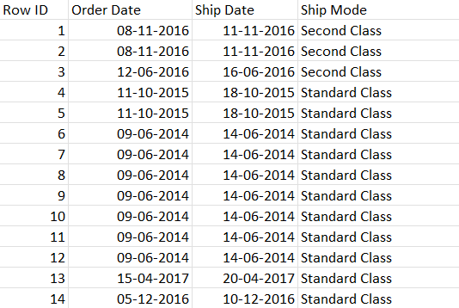AFTER CLEANING

Step 2: Data Transformation (Excel)
- Created pivot tables for aggregated views
- Built pivot charts for trend visualization
- Added slicers for dynamic filtering
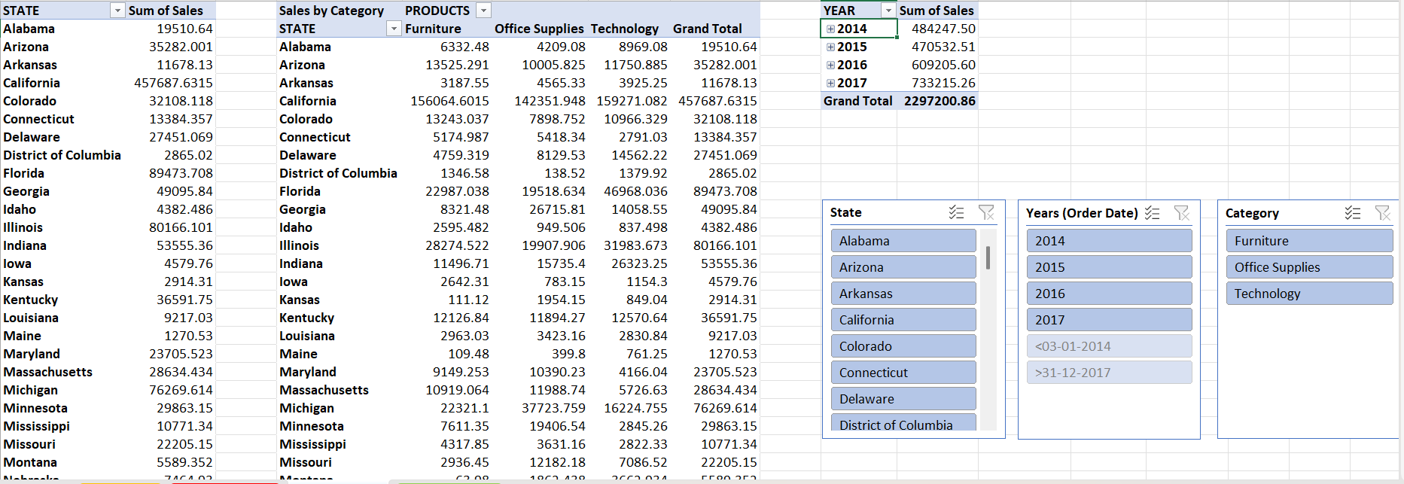
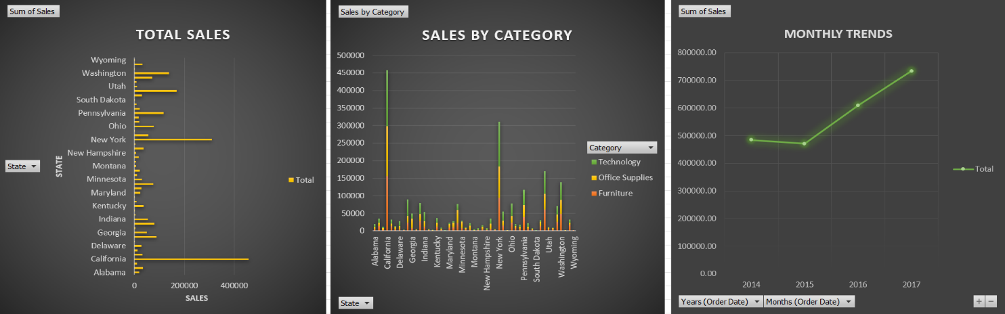
Step 3: Dashboard Development (Power BI)
- Imported cleaned dataset
- Designed visuals (line charts, bar charts, KPI cards)
- Applied custom colour palette and branding elements
- Published dashboard for weekly review
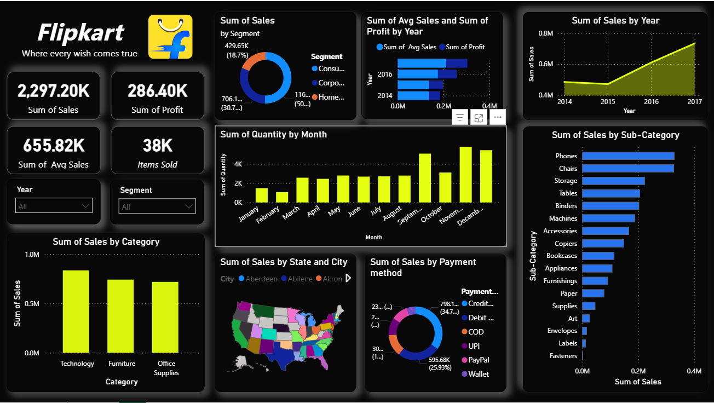
Key Insights and findings
- The total sum of sales across the dataset is approximately 2.30 million.
- Sales in 2014 were about 484.25k, showing growth over the years.
- By 2017, sales increased significantly to approximately 733.22k, indicating steady growth.
- Technology sales were the highest among all product categories, reaching 836.15k, which highlights the strong demand in this segment.
- The analysis reveals positive trends in sales, with certain categories performing exceptionally well, especially in technology and related products.
Recommendations
- Focus marketing and inventory strategies on the technology segment, which has shown the highest sales and growth potential.
- Evaluate seasonal sales patterns to optimize promotional campaigns during peak months.
- Consider expanding product lines in categories with steady growth or high demand.
- Regularly update and monitor sales data through dashboards to identify emerging trends and respond swiftly.

